**How to run This ?**

23 May 2025

11:02 PM

To Run This code properly you have to use a python notebook reader like **Jypter Notebook** or **Google Colab**.

I am choosing **Google Colab** as it's free & no need to do complex setup like Jypter Notebook.

Make sure you have a **Google Account** !

Link of Google Colab - <https://www.google.com/url?sa=t&rct=j&q=&esrc=s&source=web&cd=&cad=rja&uact=8&ved=2ahUKEwjstNzikLqNAxVNafUHHWXmMnwQjBB6BAgNEAE&url=https%3A%2F%2Fcolab.research.google.com%2F%3Fauthuser%3D1&usg=AOvVaw0nPfRj68lGbt4PItnqYTBd&opi=89978449>

Open this link and **sign in** using your existing Google Account.

Now, **open** Notebook you can see an Interface like this.

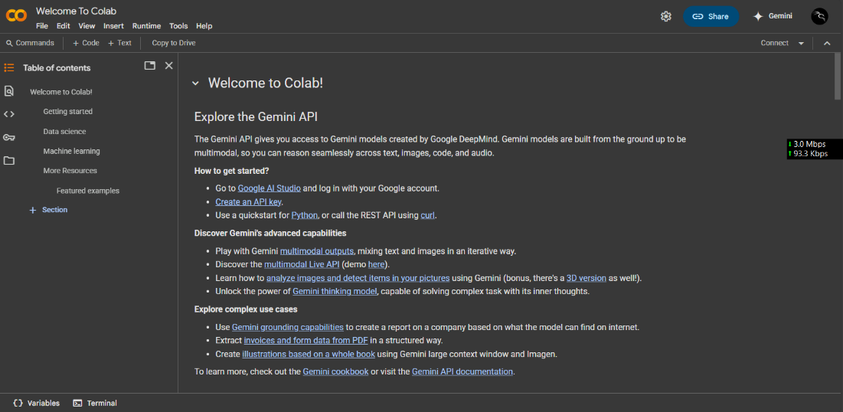

**Go to** , Files > Upload Notebook

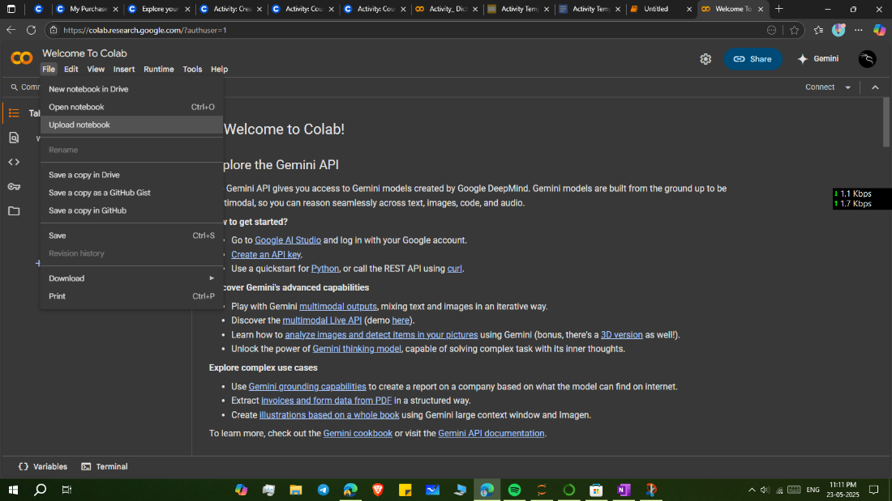

**Browse** and **select** your file (.ipynb) to open the notebook.

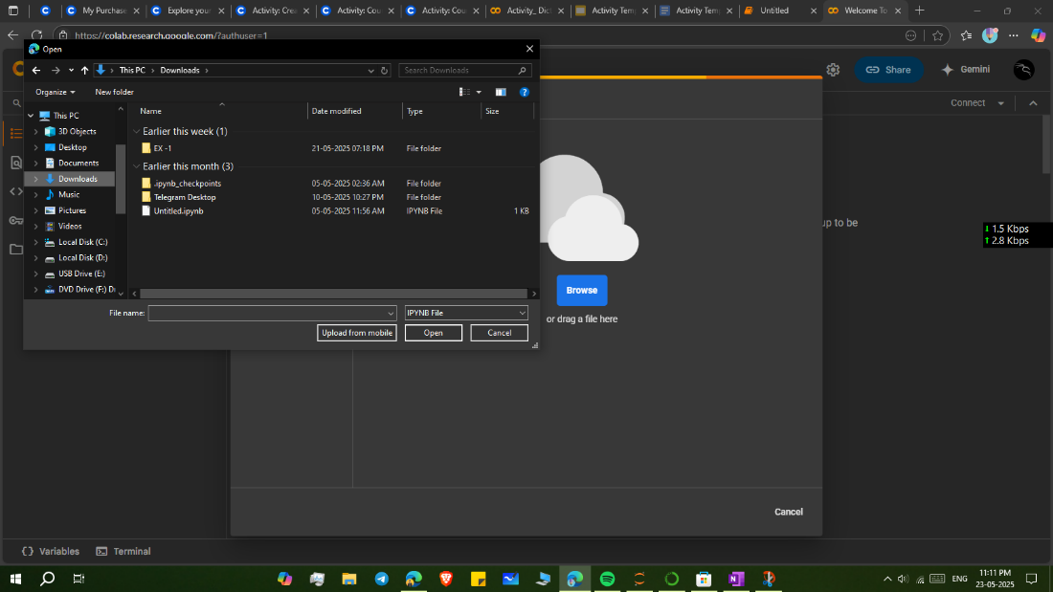

Use this "**Mount Drive**" option to mount google drive or you can manually **run** this code to "Mount Drive' also,

from google.colab import drive

drive.mount('/content/drive')

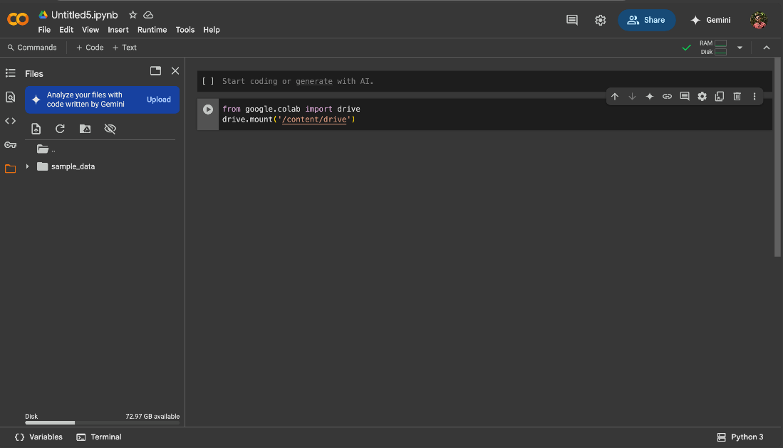

upload the **files** except ' .ipynb ' file to the path that you have just mounted by using drive or you can just **drag on drop** on this here.

Make sure the path must be same otherwise It will not work.

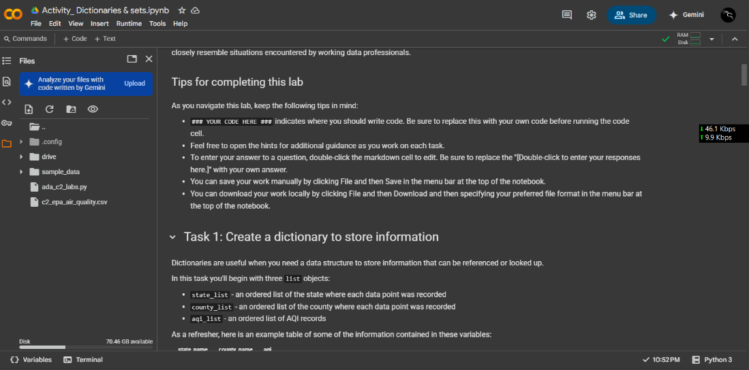

Now, you are ready to **run** the code and start explore my works.

Thank You.

















